* **DropDown Tree Implementation For Matrix**

**Step : 1** Add the Plugins to implement JsTree to DropDown Tree.

* UI  
  In wwwroot folder Add Plugin CSS and Js Files  
  Folder Path : wwwroot\plugins\DropdownTree  
    
  File Name: dropdowntree.css  
   dropdowntree.js

**Step : 2** Add div tag for Dropdown tree View in .cshtml file.

(eg. <div id="YourDivId" class="dropdown dropdown-tree"></div>)

* Add the Js code to set the data in the dropdown tree plugin.
* Here is the screen shot for the js code.

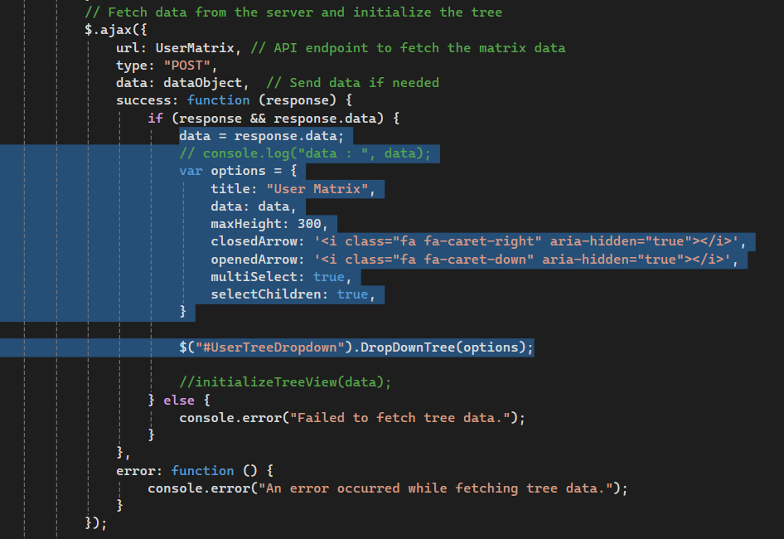

**Step : 3** Here need to set the Proper plugins format data from the Controller side

And pass it into the Tree Dropdown JS.

* For Plugin format data check the below method code.
* (Method path : MatrixService.cs/GetTreeDropdown())

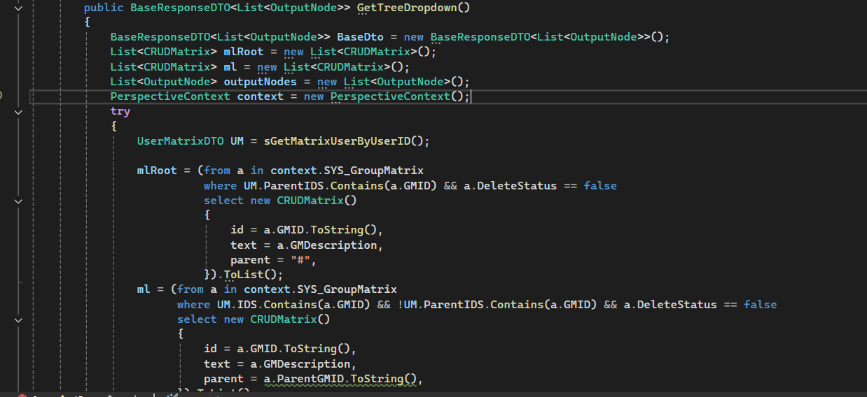

**Step : 4** Here is the screen shot for Final outPut of Dropdown tree.

